Sumaré, 21 de Fevereiro de 2024 

Maria Eduarda Rodrigues Brito

Projeto: **SETA E PISCA ALERTA DO CARRO- TRASEIRA E FRONTAL (programação média)**

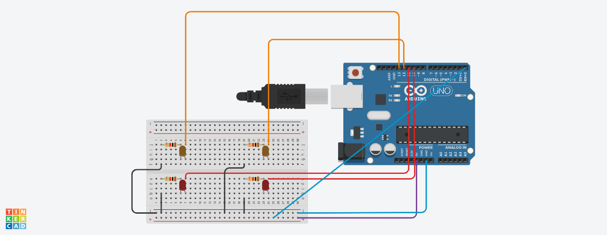

const int btn1 = 0;

int cond = 0;

void setup()

{

pinMode(13, OUTPUT);

pinMode(12, OUTPUT);

pinMode(11, OUTPUT);

pinMode(10, OUTPUT);

pinMode(btn1,INPUT);

}

void loop()

{

cond = digitalRead(btn1);

if (cond == HIGH)

digitalWrite(13, HIGH);

digitalWrite(12, LOW);

digitalWrite(11, HIGH);

digitalWrite(10, LOW);

delay(1000);

digitalWrite(13, LOW);

digitalWrite(12, HIGH);

digitalWrite(11, LOW);

digitalWrite(10, HIGH);

delay(1000);

digitalWrite(13, HIGH);

digitalWrite(12, HIGH);

digitalWrite(11, HIGH);

digitalWrite(10, HIGH);

delay(1000);

digitalWrite(13, LOW);

digitalWrite(12, LOW);

digitalWrite(11, LOW);

digitalWrite(10, LOW);

delay(1000);

digitalWrite(13, HIGH);

digitalWrite(12, HIGH);

digitalWrite(11, HIGH);

digitalWrite(10, HIGH);

delay(1000);

digitalWrite(13, LOW);

digitalWrite(12, LOW);

digitalWrite(11, LOW);

digitalWrite(10, LOW);

delay(1000);

}